PIE
PATENT INFORMATION EXTRACTION FORM
TOPIC : Autonomous Neuromorphic Underwater Coral Restoration System with Event-Based Detection and Adaptive Indexed Pod Deployment
SCHOOL: Chitkara University Institute of Engineering and Technology
INVENTOR’S DETAIL WHO UPLOADED THE PATENT ON CHALKPAD
NAME: Shikha Tuteja
EMPLOYEE CODE: CET1002580 MOBILE NO: 9915369888
MAIL ID (UNIVERSITY): shikha.1290@chitkara.edu.in
MAIL ID (PERSONAL): shikha.1290@chitkara.edu.in
OTHER INVENTORS DETAIL
NAME | EMP CODE/ROLL | ADDRESS WITH EMAIL AND MOBILE NO.
Subham Das | 2210992411 | subham2411.be22@chitkara.edu.in 9002964762
Shivansh Bhatia | 2210992319 | shivansh2319.be22@chitkara.edu.in 9568477210
Shivaanjay Narula | 2210992302 | shivaanjay2302.be22@chitkara.edu.in 8580457634
Shikha Tuteja | CET1002580 | shikha.1290@chitkara.edu.in 9915369888
Prabir Maity | 2250951013 | prabir22013.ccp@chitkara.edu.in 8945527815
Soumarshi Das | 2250951019 | soumarshi22019.ccp@chitkara.edu.in 6297213177

Answer the following questions in brief: (use extra sheets if needed, submit pics/videos etc. which can help us to understand the invention better)

- What was the problem?

- At present, underwater coral monitoring systems operate in a semi-autonomous manner where robots capture images and transmit them to a remote server for human analysis. Based on the analysis, divers are later deployed to the identified location to perform coral regeneration manually.

- This multi-step process causes significant delay between detection and restoration, increases operational cost, requires human intervention, and limits scalability.
- Furthermore, traditional image-based systems rely on frame-based cameras and cloud processing, leading to high energy consumption, increased bandwidth requirements, and reduced real-time responsiveness.

- There is no integrated autonomous system capable of detecting coral degradation in real time and immediately performing controlled, on-site restoration without external human decision-making.

- How did you solve it (Inventive Step)?

- The problem was solved by developing an autonomous underwater system integrating an event-based vision sensor with a Spiking Neural Network (SNN) processor for real-time coral health assessment.

- Unlike conventional frame-based imaging systems that require high bandwidth and cloud-based processing, the proposed system performs on-device neuromorphic processing to detect coral degradation with reduced power consumption and latency.

- Upon classification of a damaged or decomposed coral region, the system executes a confidence-based decision algorithm that activates an indexed X-Y electric gantry mechanism to deploy a predetermined number of coral restoration pods directly at the detected location.

- The deployment mechanism is adaptive and controlled by a microcontroller-based logic system that ensures precise multi-pod release while preventing redundant deployment at previously treated coordinates.

- This integrated detection-to-restoration architecture eliminates human intervention and enables real-time, energy-efficient, and scalable coral rehabilitation.

- What were the other possible solutions and why they could not be done?

- Several alternative solutions were considered for coral monitoring and restoration.

- One approach involved using conventional frame-based cameras with CNN-based image processing and transmitting captured images to a remote server for analysis. However, this method requires high bandwidth, continuous data transmission, and significant computational power, making it energy-intensive and unsuitable for long-duration autonomous underwater missions.

- Another possible solution was manual diver-based inspection and restoration. While effective at small scales, this method is slow, costly, labor-intensive, and not scalable for large reef ecosystems.

- A third alternative involved simple underwater robots that deploy coral fragments at fixed intervals without intelligent health assessment. Such systems lack adaptive decision-making and may result in inefficient or redundant deployment.

- Hydraulic-based deployment mechanisms were also considered for pod release; however, these systems introduce complexity, leakage risks, higher maintenance requirements, and increased weight, making them less suitable for compact autonomous underwater devices.

- Due to these limitations, an integrated neuromorphic event-driven detection system combined with an electric indexed deployment mechanism was developed to provide energy-efficient, real-time, and adaptive coral restoration.

- What are the advantages of the solution proposed by you?

- Real-Time Autonomous Operation: The system detects coral degradation and performs restoration on-site without requiring remote server analysis or human intervention.

- Energy Efficiency: The use of an event-based camera combined with a Spiking Neural Network (SNN) reduces data processing and power consumption compared to conventional frame-based imaging systems.

- Reduced Latency: On-device neuromorphic processing eliminates the delay associated with transmitting images to external servers for analysis.

- Adaptive Deployment Mechanism: The indexed X-Y electric gantry enables precise and controlled multi-pod release based on damage severity and confidence levels.

- Scalability: The system can operate continuously across large reef areas without the need for manual diver-based restoration.
- Improved Deployment Accuracy: Location memory and confidence-based decision logic prevent redundant or unnecessary pod deployment.

- Mechanical Reliability: The electric indexing mechanism offers simpler design, lower maintenance, and reduced leakage risk compared to hydraulic systems.

- Bandwidth Optimization: Since only event-based changes are processed, communication requirements are significantly minimized.

- Integrated Detection-to-Restoration Architecture: Unlike conventional systems that separate monitoring and restoration, the invention combines both into a unified autonomous platform.

- Explain the stepwise working of the innovation explaining all the components used in the invention and the specific function they are performing.

- Step 1: Underwater deployment and mobility : The device is deployed underwater and navigates to targeted reef areas using thruster-based propulsion.
Components used:
- Waterproof pressure-sealed enclosure
- Thrusters (vectored fans) + ESC drivers
- IMU (orientation/tilt)
- Depth/pressure sensor
- Battery pack + power management module
Function: Provides stable underwater movement, depth holding, and electrical power distribution.

- Step 2: Real-time reef scanning using event-driven vision :The device continuously scans coral surfaces using an event-driven camera. Only pixel-level intensity changes are captured, reducing data load.
Components used:
- Event-driven camera module
- Dual LED illumination (fixed)
- Optical lens and mounting frame
Function: Detects coral texture change, loss of living tissue, fragmentation, and low biological activity with low power and low latency.

- Step 3: Coral spawning/egg sensing mode (optional module) :When the system enters a spawning window or detects a local particle increase, it activates the spawning/egg detection module.
Components used (possible solution):
- Macro optical sensor / micro-camera + LED
- Turbidity/particle sensor (flow-through)
- Micro-pump + micro-filter sampling chamber (optional)
Function: Detects coral gamete bundles/larvae presence through optical classification and/or particle change confirmation, and logs spawning locations for research and future restoration planning.

- Step 4: Neuromorphic processing and coral health classification :
The event stream (and optional egg sensor data) is processed locally using a Spiking Neural Network (SNN) running on the onboard processor.
Components used:
- SNN / neuromorphic processing unit (AI chip)
- Embedded MCU (ESP32/STM32) for control
- Local storage (Flash/SSD)
Function: Classifies coral health as Healthy / Damaged / Decomposed and generates a confidence score for decision-making.

- Step 5: Decision logic and safety checks: When coral is classified as decomposed/damaged, the microcontroller performs control checks before deploying pods.
Decision conditions include:
- Confidence score above threshold
- Stable hovering (IMU + depth confirmation)
- No obstacle/jam detection
- Treated-location verification (memory)
Components used:
- MCU firmware logic
- Jam detection sensor (gate/gantry feedback)
- Localization/mapping module
Function: Prevents false deployment, duplicate deployment at the same spot, and ensures safe operation.

- Step 6: X–Y electric gantry indexing to select pods (10×10 grid) :
After confirmation, the indexed electric gantry positions itself to the selected pod coordinates in the 10×10 storage grid.
Components used:
- X-axis stepper motor + linear rail
- Y-axis stepper motor + linear rail
- Position encoder/limit switches
- Pod storage grid (100 box pods)
Function: Provides accurate positioning for controlled pod selection and avoids mechanical misalignment.

- Step 7: Automatic multi-pod release (10 pods) : Once aligned, the system releases exactly 10 pods through the dispensing gate.
Components used:
- Servo-actuated release gate
- Pod counter sensor (IR/limit/hall)
- Discharge chute/outlet port
Function: Ensures precise quantity-based deployment for coral regeneration while avoiding over-release.

- Step 8: Logging, mapping, and communication :The device stores the event data, coral health status, pod count released, and the treated location. If communication is available, it transmits summary data to a surface/server.
Components used:
- Storage module (SSD/Flash)
- Communication module (acoustic modem / RF at surface)
- GPS at surface + underwater localization (as available)
Function: Maintains restoration records, enables revisit planning, and supports long-term reef monitoring.

- Step 9: Continue scanning : The device resumes scanning and repeats the above steps for new damaged coral regions.

- Attach drawing hand-made/ computer made showing all the components of the
invention.

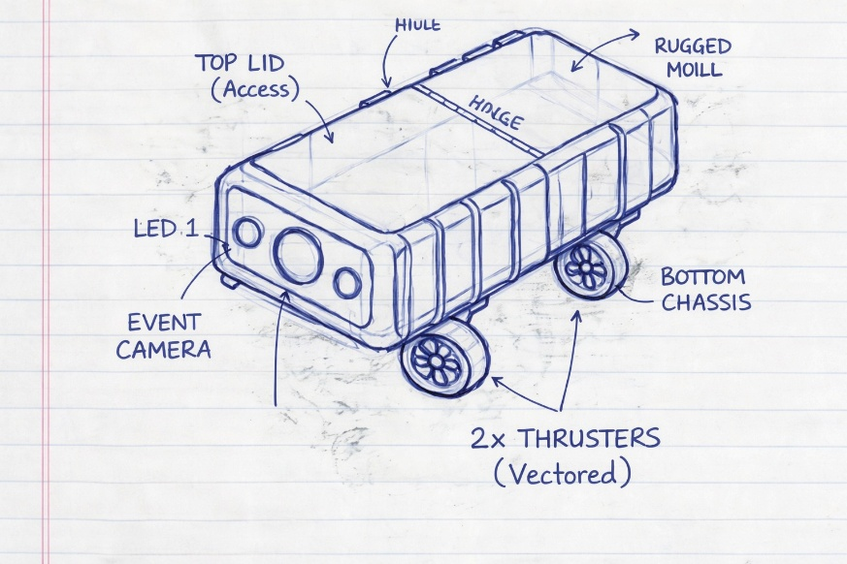

Figure 1: A rugged coral restoration device featuring a top-access hinged lid, front-mounted event-driven camera with dual LEDs, and vectored thrusters for stable navigation and deployment.

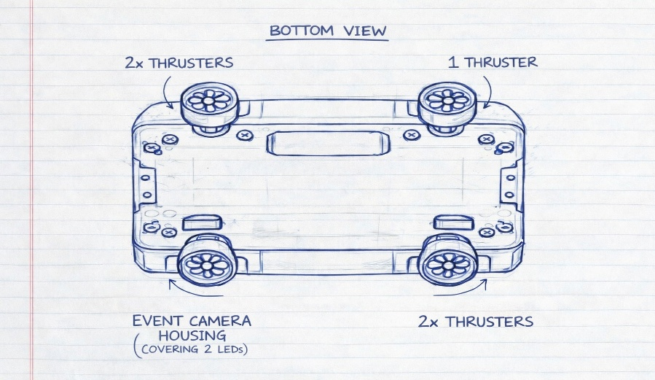

Figure 2: Bottom view showing four vectored thrusters and a protected event camera housing with dual LED coverage for underwater stability and vision.
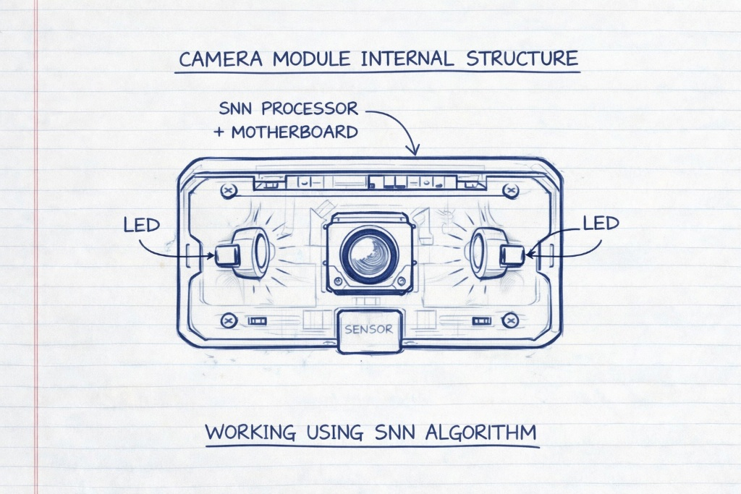

Figure 3: Internal camera module featuring a central event-driven sensor with dual LEDs and an integrated SNN processor for real-time underwater reef analysis.

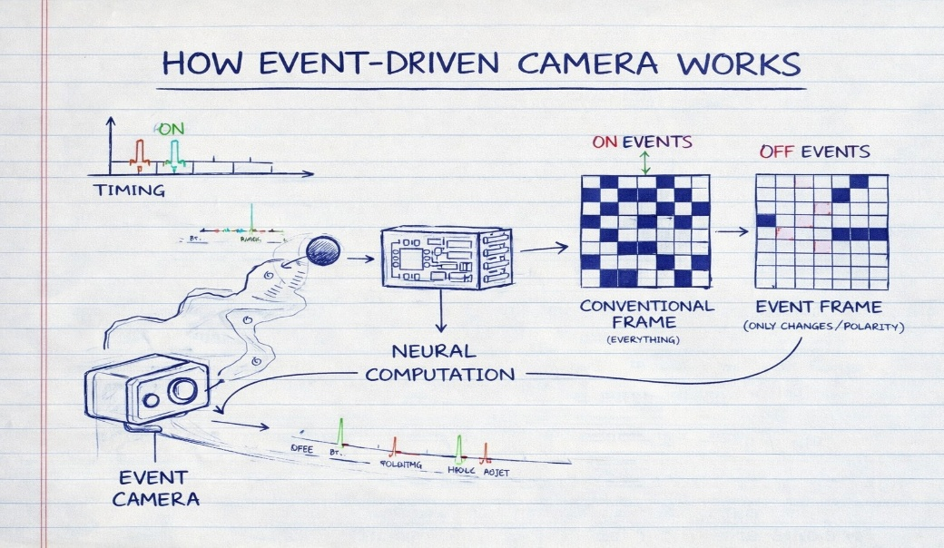

Figure 4: Event-driven camera detects only pixel-level brightness changes (ON/OFF events) and converts them into spike-based neural signals for fast, efficient processing instead of capturing full image frames.

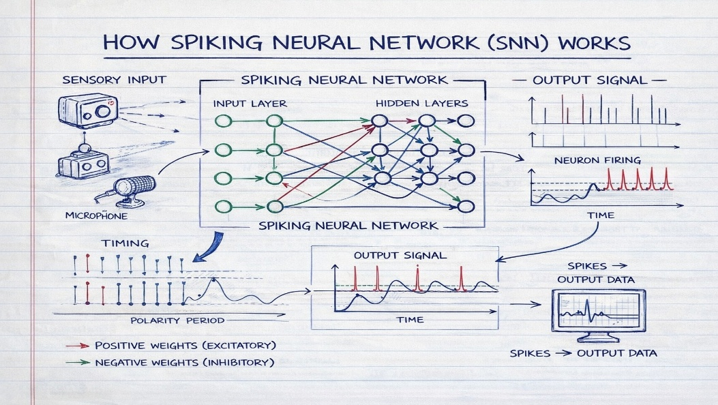

Figure 5: A Spiking Neural Network (SNN) processes time-based sensory inputs as discrete spikes, using excitatory and inhibitory neuron firing patterns to generate efficient, event-driven output signals.

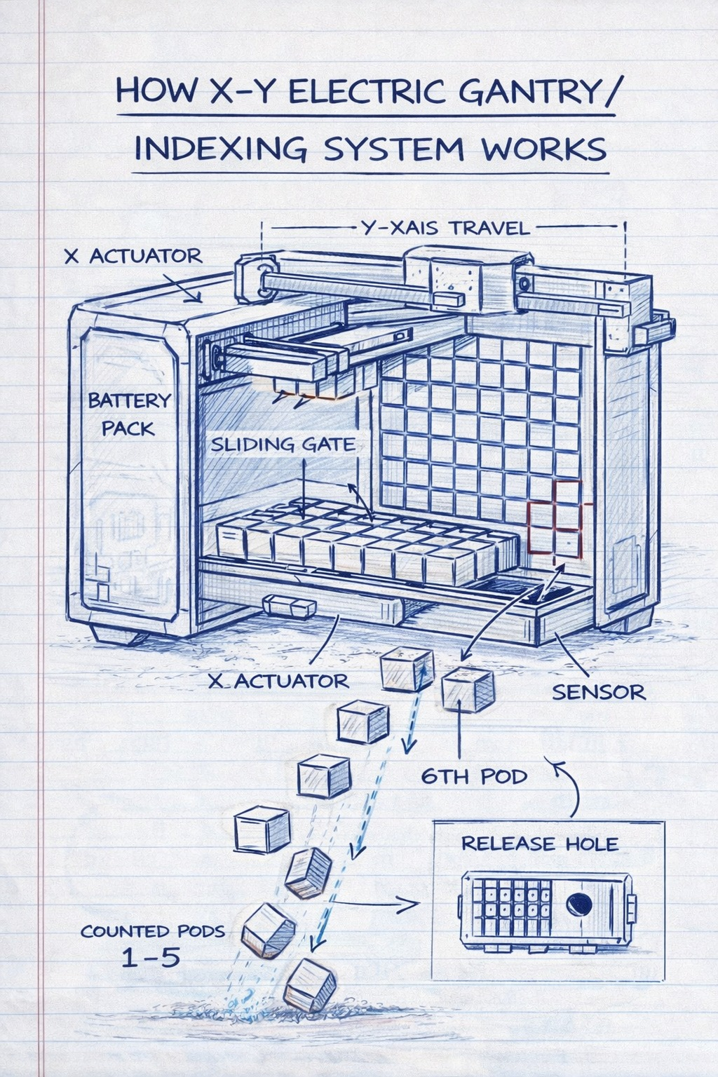

Figure 6: The X–Y electric gantry indexing system precisely moves across a pod grid using actuators and sensors to align and release selected coral pods through a controlled deployment hole.

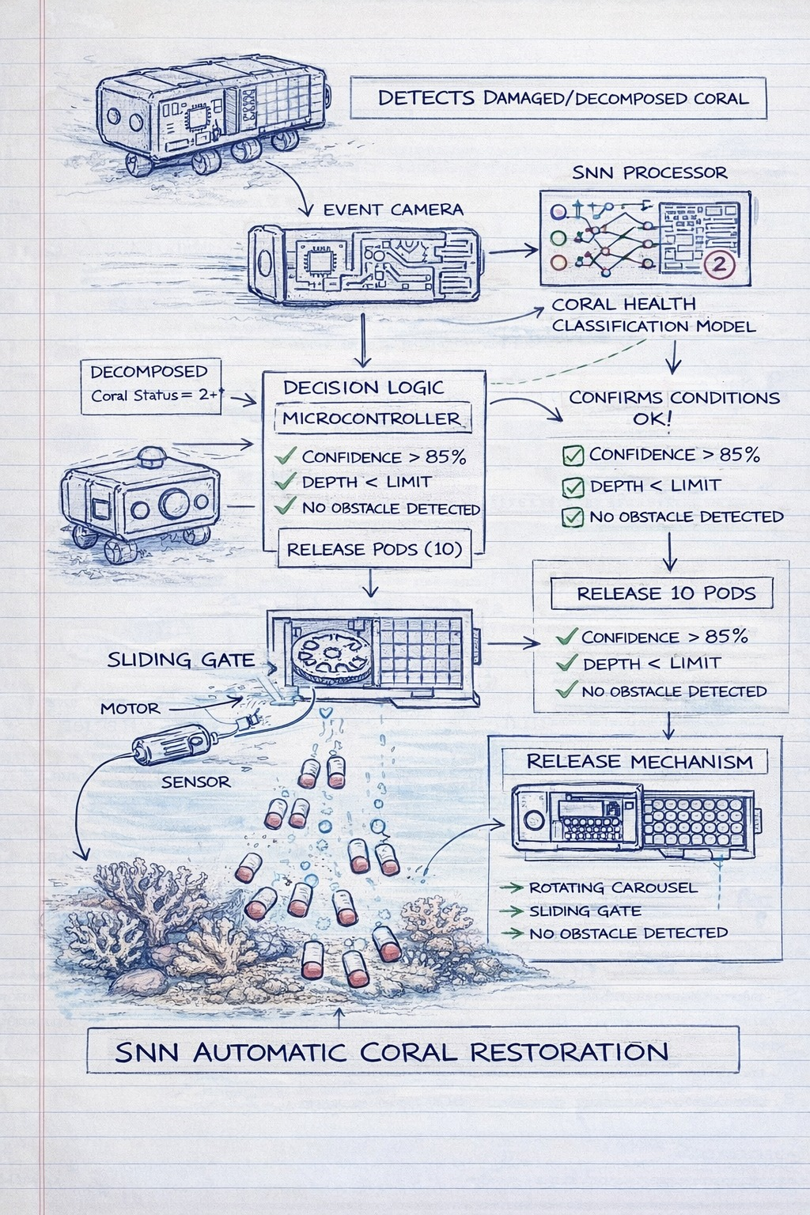

Figure 7 : An SNN-based autonomous system detects damaged coral, validates environmental conditions, and automatically deploys biodegradable pods through a controlled release mechanism for reef restoration.

Relevant Key phrases relating to your invention

S.NO. | Key phrases
 | Neuromorphic Event-Based Underwater Coral Detection System
 | Autonomous SNN-Based Real-Time Coral Health Classification
 | Adaptive X–Y Indexed Electric Gantry Pod Deployment Mechanism
 | Integrated Detection-to-Restoration Autonomous Marine Rehabilitation Platform

